**Section 2–8A: Linear Inequalities**

**Introductions:**

In some situations you need to compare quantities. You can use inequalities for situations that involve these relationships: *less than* ($<$), *less than or equal to* ($≤$), *greater than* ($>$), and *greater than or equal to* ($≥$).

Graphing an inequality in two variables is similar to graphing a line. The graph of a linear inequality contains all points on one side of the line and may or may not include the points on the line.

A **linear inequality** is an inequality in two variables whose graph is a region of the coordinate plane bounded by a line. This line is the **boundary** of the graph. The boundary separates the coordinate plane into two **half-planes**, one of which consists of solutions of the inequality.

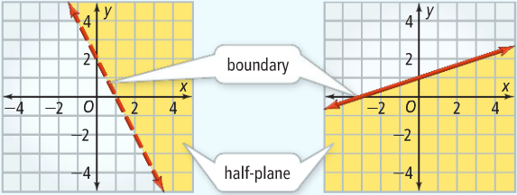

To determine which half-plane to shade, pick a **test point** that is *NOT* on the boundary. Check whether that point satisfies the inequality. If it does, shade the half-plane that includes the test point. If not, shade the other half-plane. **The origin, $(0, 0)$, is usually an easy test point as long as it is not on the boundary**.

**Example 1: Graphing Linear Inequalities**

What is the graph of each inequality? (a) $y>3x-1$ and (b) $y≤3x-1$

$y>3x-1$

**Step 1: graph the boundary line**

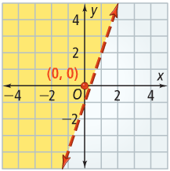You should use a dashed boundary line because the inequality is *greater than*, and the points on the line doe not satisfy the inequality.

**Step 2: choose a test point, $(0, 0)$**

Substitute $x=0$ and $y=0$ into $y>3x-1$.

$0>3\left(0\right)-1$

$0>-1$

Since $0>-1$ is true, shade the half-plane that includes $(0, 0)$.

$y≤3x-1$

**Step 1: graph the boundary line**

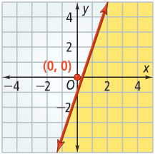You should use a solid boundary line because the inequality is *less than or equal to*, and the points on the line doe satisfy the inequality.

**Step 2: choose a test point, $(0, 0)$**

Substitute $x=0$ and $y=0$ into $y≤3x-1$.

$0≤3\left(0\right)-1$

$0≤-1$

Since $0≤-1$ is false, shade the half-plane that DOES NOT includes $(0, 0)$.

You can also inspect inequalities solved for $y$, such as $y>mx+b$ to determine which half-plane describes the solution. Since $y$ describes vertical position, the solution of $y>mx+b$ will be ***above***the boundary line. The solution of $y<mx+b$ will be ***below***the boundary line.

**Example 2: Using Linear Inequality**

**ENTERTAINMENT:** the map shows the number of tickets needed for small or large rides at the fair. You do not want to spend more than $15 on tickets. How many small or large rides can you ride?

Since each ticket is $0.25, you can buy 60 tickets with $15.

**Define:** Let *x* = the number of small rides.

Let *y* = the number of large rides.

**Relate:** # of tickets for small rides plus # of tickets for large rides is less than or equal to 60

**Write: $3x+5y≤60$**

**Step 1: find the intercepts and use it to graph the boundary line**

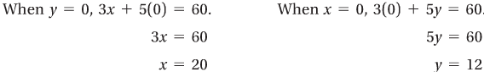

Graph the line that connects the intercepts $(20, 0)$ and $(0, 12)$. Since the inequality is $≤$, use a solid boundary line.

**Step 2: interpretation of the graph**

The region above the boundary line represents combinations of rides that require more than 60 tickets. You purchased a ***finite*** number of tickets, 60, so you will not be able to go on an infinite number of rides. **Shade the region below the boundary line**.

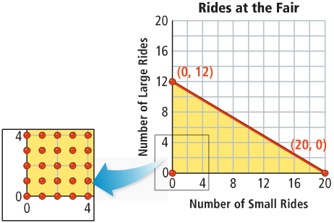

The number of small rides *x* and the number of large rides *y* are **whole numbers**. In math, such a situation is called *discrete*. All points with whole number coordinates in the shaded region represent possible combinations of small and large rides.